Education 231E: Discussion Section
Week 1: Introduction to Mplus Graphics

Histograms of variables from Reading Data Example

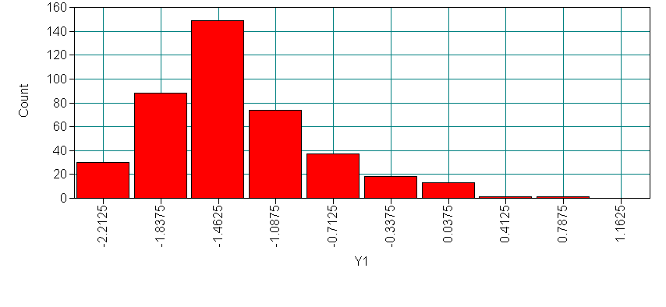
Example of a Histogram/Density Plot 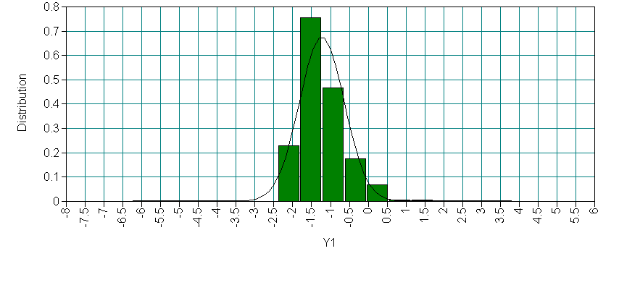
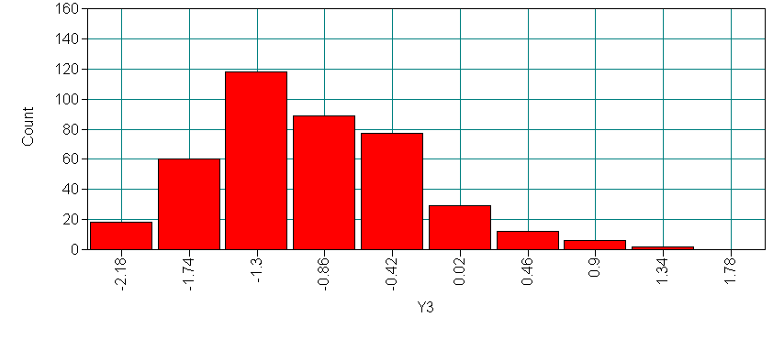
Histogram of Y11 with the y-axis changed to be the same as other variables.
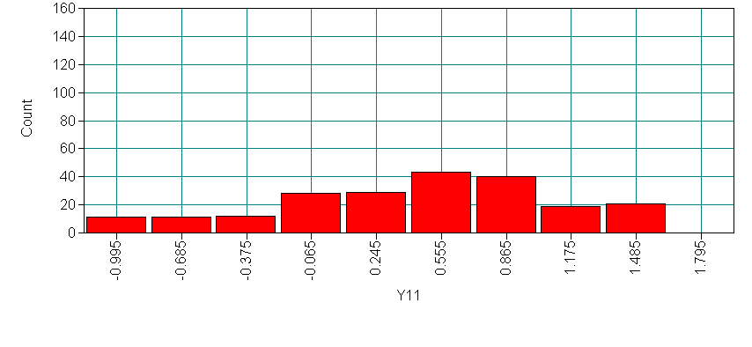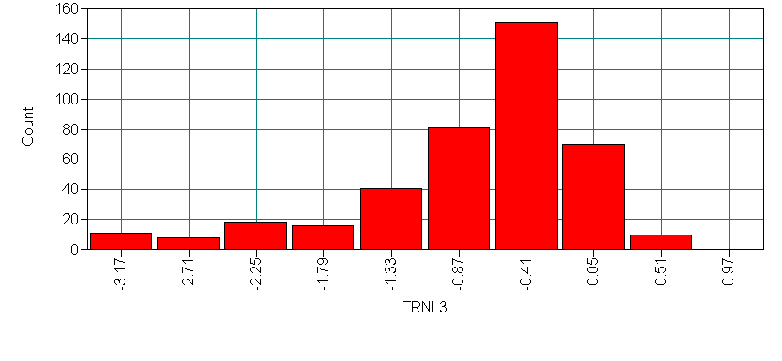

Scatter plots of variables from Reading Data Example

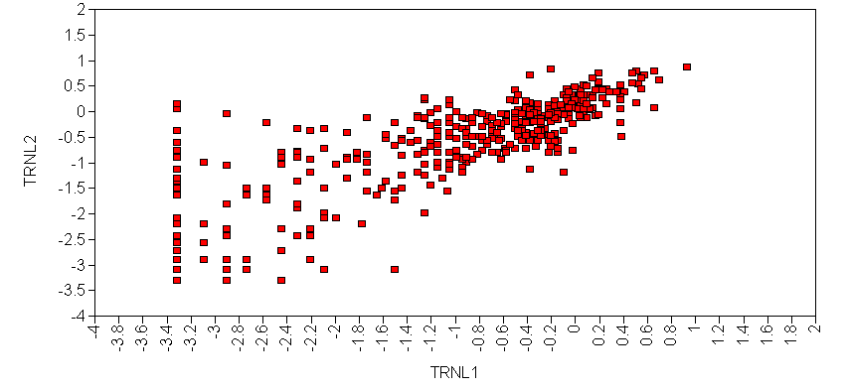
Scatter plot with colors and symbols changed with Descriptive statistics included.
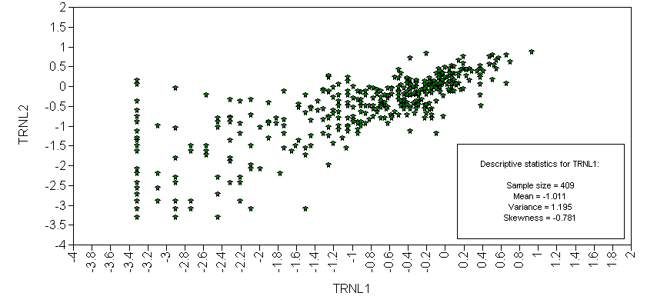
Below is a scatter plot of a random subset of 50 subjects. This is especially useful if there are many subjects in the sample. You can subset by a random

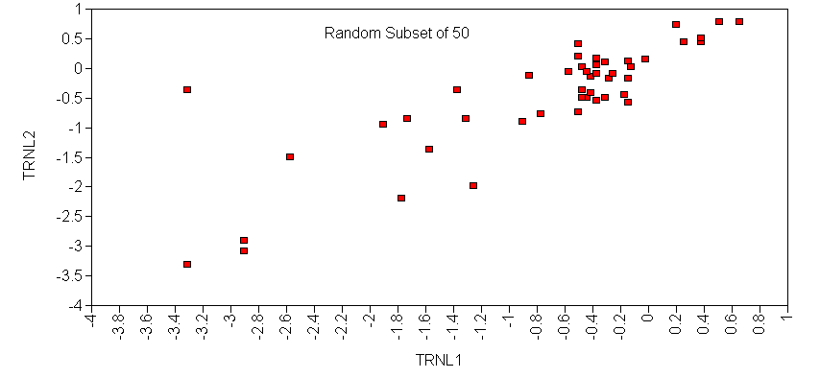

updated 4/4/04 (KLN)

